Yangli and you meet in Beijing
2016-06-02 Yang group administrative micro-blog
China International Machine Tool Exhibition (CIMES2016)
China International Machine Tool Exhibition (CIMES) is the third largest international machine tool exhibition after the EMO in Germany and the IMTS exhibition in Chicago. CIMES Exhibition for the global advanced manufacturing industry in the world's largest consumer and producer of machine tool - Chinese, providing a truly international machine tool production, automation control integrated display and trading platform, will allow you to efficiently preview, visit and seek the world's leading enterprises display digital integrated workshop concept, the latest products, technologies and solutions and China production the efficient machine, to improve your efficiency and competitiveness of enterprises.

CIMES2016 will be unveiled at the New International Exhibition Center in Beijing on 22-26 June 2016. Since 1992 China International Machine Tool Exhibition (CIMES) held in Beijing every year, at home and abroad by users and equipment manufacturing, trade and circulation enterprises welcome and support. After 20 years of development, CIMES the degree of internationalization of the exhibition has been a qualitative leap, 2016 will be unprecedented.
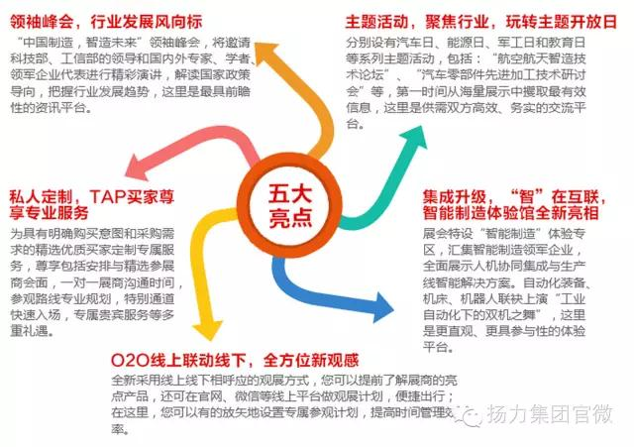

Yangli and you meet in Beijing
Time: 22~26 June 2016
Location: Beijing International Exhibition Center (new pavilion)
Yangli group booth No.: W3A101
Booth area: 325 square meters
Be all eagerness to see it

The Longmen Yangli group will bring high performance press JM36-200, press CP1-63, high performance open NC fiber laser cutting machine ML3015F, CNC servo turret punch, CNC EP20 servo pump control YHB1032, bending machine hydraulic servo machine YGM-315K unveiled the exhibition.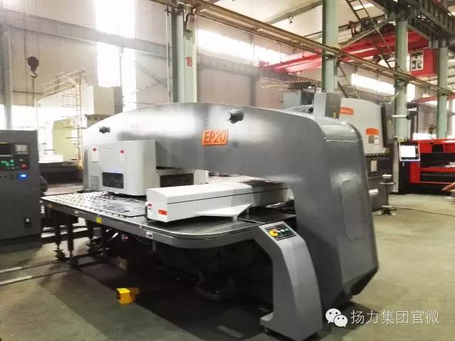
CNC servo turret punch press EP20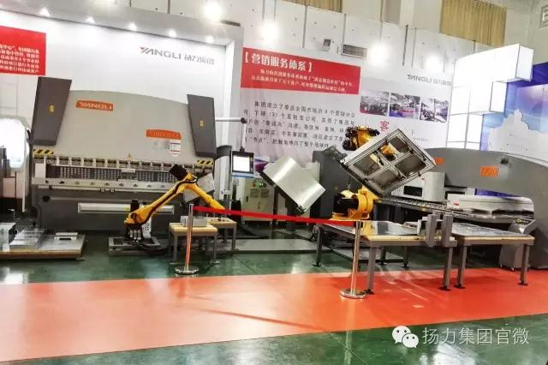
CNC servo pump control bending machine YHB1032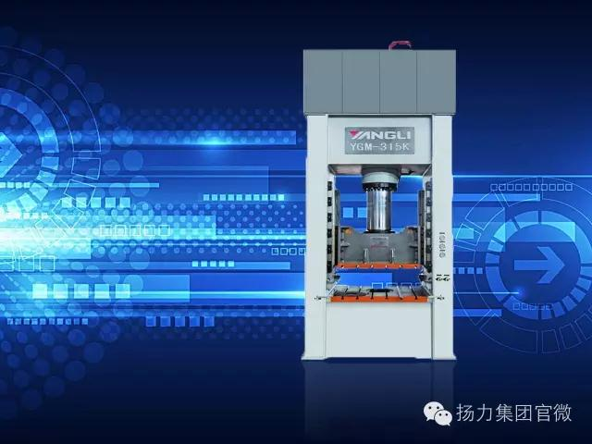
Servo hydraulic press YGM-315K

Surprises
We invite you to visit Yang Group booth (Booth No.: W3A101), immediate registration, a special gift can be recorded by booth to receive Yang Group for you oh!
A two-dimensional code, a two-dimensional code, can be entered.

